Chapter 6, Solution 7.

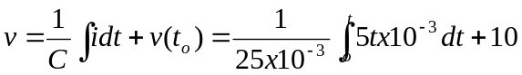

= 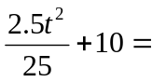[0.1t² + 10] V.

